Java 9 Features

**Java 9 REPL(JShell)** :

Java released Read Evaluate Print Loop(REPL) just like node REPL and python repl to compile and run the programs JIT.

Eg.

G:\>jshell | Welcome to JShell -- Version 9-ea

| For an introduction type: /help intro

jshell> int a = 10 a ==> 10

jshell> System.out.println("a value = " + a ) a value = 10

**Factory Methods for Immutable List, Set, Map and Map.Entry**:

In Java SE 8 and earlier versions, We can use Collections class utility methods like unmodifiableXXX to create Immutable Collection objects. For instance, if we want to create an Immutable List, then we can use Collections.unmodifiableList method.

However, these Collections.unmodifiableXXX methods are a tedious and verbose approach. To overcome those shortcomings, Oracle Corp has added a couple of utility methods to List, Set and Map interfaces.

**Private methods in Interfaces**:

In Java .we can have default as well as private methods within an interface:

Advantages :

Code reuse

Reduces redundancy of duplicacy of code across all clients.

**Java 9 Module System:**

* A module is a set of packages designed for reuse – Alex Buckley
* Strong encapsulation
* Access control is more powerful
* Reliable dependencies and no missing dependencies
* No Split packages, means if there are 2 packages imported from 2 imports sometimes java loads classes from 1 package and some from another.
* Run with java -p mods -m hello.world
* Monolithic JDK is broken into modules
* java.base is base framework
* When we expose a package via jar we expose all public classes of that package to the outer world which may not always be the case.

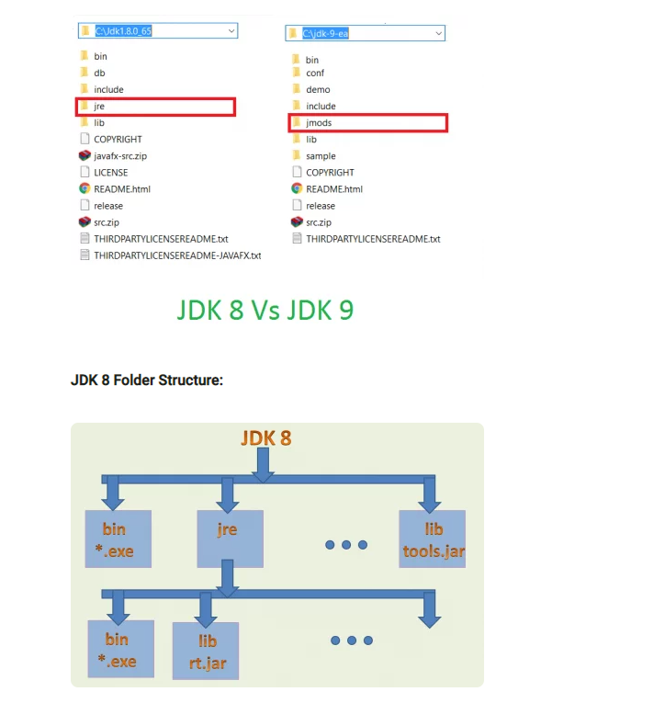

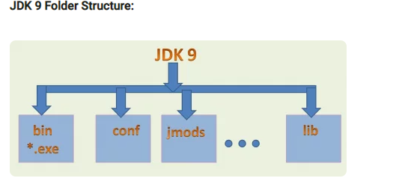

Adavantages : Only use exported packages via modules

**Improved Javadocs** :

Since java 8 bwe can have default methods other than abstracty methods in Interfaces.

Default methods are used so that functionality can be added to existing interfaces / implementations without the existing implementations to implement those.

Helped with the evolution of existing interfaces such as List etc where foreach was added so that the interfaces remain backward compatible and the new implementation can be used as well